**Creating Microservices for account and loan**

In this hands on exercises, we will create two microservices for a bank. One microservice for handing accounts and one for handling loans.

Each microservice will be a specific independent Spring RESTful Webservice maven project having it's own pom.xml. The only difference is that, instead of having both account and loan as a single application, it is split into two different applications. These webservices will be a simple service without any backend connectivity.

**Program: For Account Microservice**

**AccountController.java**

package com.cognizant.account.controller;

import org.springframework.web.bind.annotation.*;

@RestController

@RequestMapping("/accounts")

public class AccountController {

@GetMapping("/{number}")

public Account getAccount(@PathVariable String number) {

return new Account(number, "savings", 234343);

}

static class Account {

private String number;

private String type;

private double balance;

public Account(String number, String type, double balance) {

this.number = number;

this.type = type;

this.balance = balance;

}

public String getNumber() {

return number;

}

public String getType() {

return type;

}

public double getBalance() {

return balance;

}

}

}

**AccountApplication.java**

package com.cognizant.account;

import org.springframework.boot.SpringApplication;

import org.springframework.boot.autoconfigure.SpringBootApplication;

@SpringBootApplication

public class AccountApplication {

public static void main(String[] args) {

SpringApplication.*run*(AccountApplication.class, args);

}

}

**Output:**

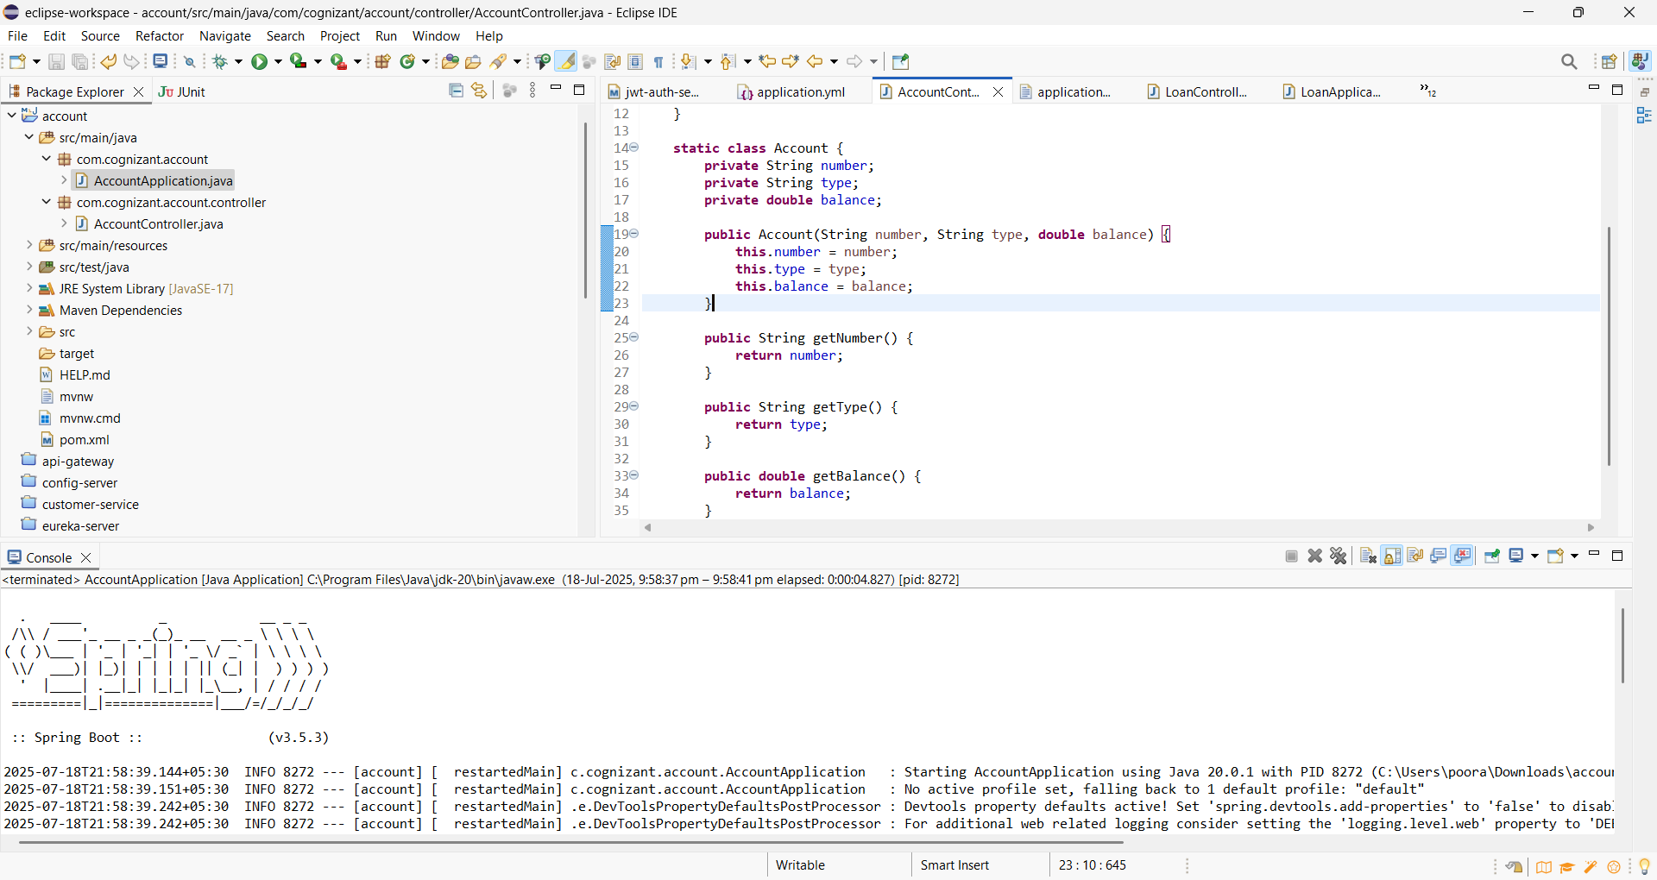

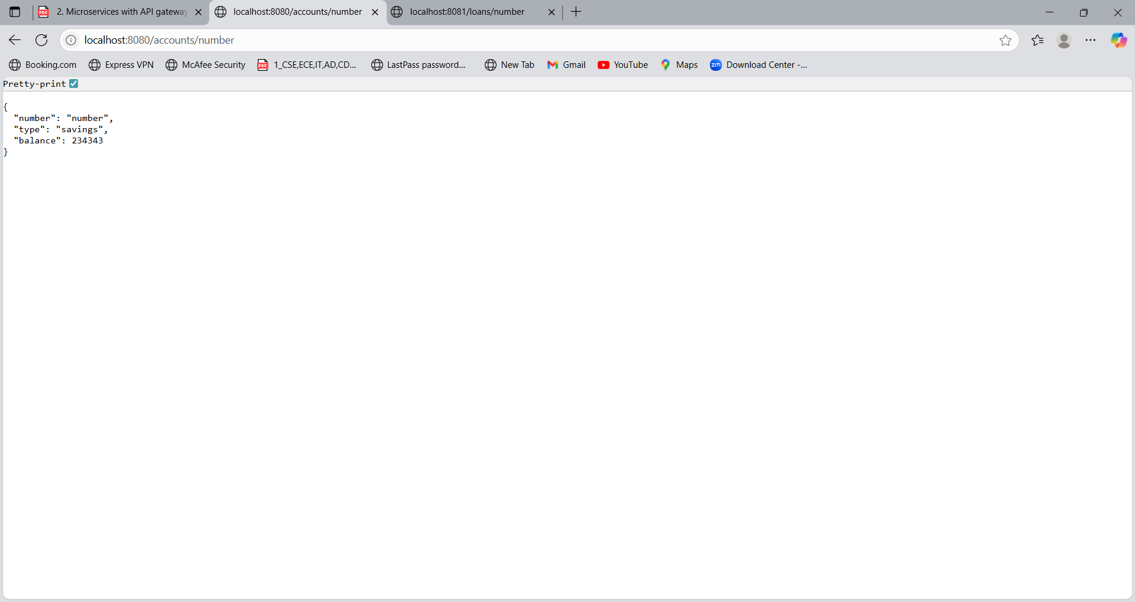

**Program : For Loan Microservice**

**LoanController**

package com.cognizant.loan.controller;

import org.springframework.web.bind.annotation.*;

@RestController

@RequestMapping("/loans")

public class LoanController {

@GetMapping("/{number}")

public Loan getLoan(@PathVariable String number) {

return new Loan(number, "car", 400000, 3258, 18);

}

static class Loan {

private String number;

private String type;

private int loan;

private int emi;

private int tenure;

public Loan(String number, String type, int loan, int emi, int tenure) {

this.number = number;

this.type = type;

this.loan = loan;

this.emi = emi;

this.tenure = tenure;

}

public String getNumber() {

return number;

}

public String getType() {

return type;

}

public int getLoan() {

return loan;

}

public int getEmi() {

return emi;

}

public int getTenure() {

return tenure;

}

}

}

**LoanApplication.java**

package com.cognizant.loan;

import org.springframework.boot.SpringApplication;

import org.springframework.boot.autoconfigure.SpringBootApplication;

@SpringBootApplication

public class LoanApplication {

public static void main(String[] args) {

SpringApplication.*run*(LoanApplication.class, args);

}

}

**Output:**



